## Web Application Architecture

The request is routed to a server and processed by ASP.Net API service running on the server

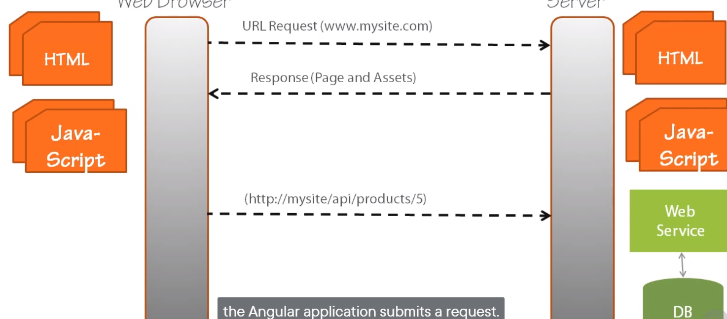

If the request is for data, the web API retrieve that data potentially from a database, and returns it to the angular application, that data is provided is JSON or JavaScript Object Notation

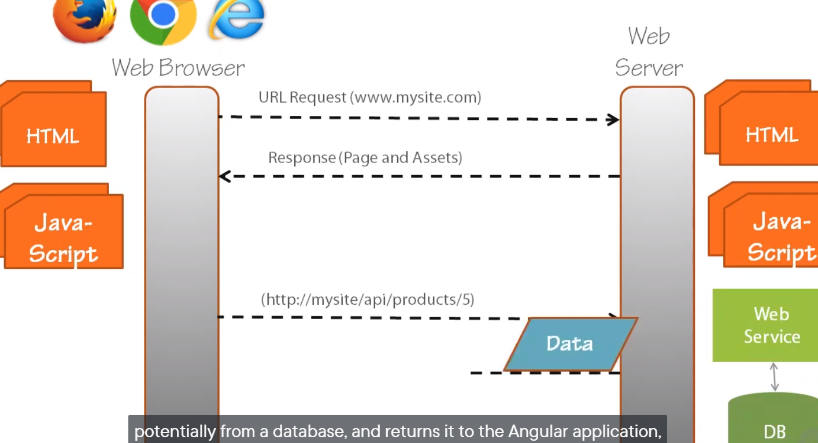

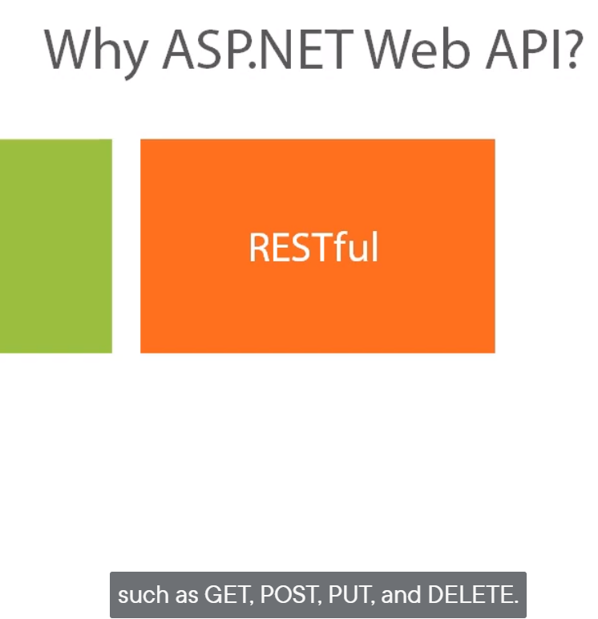

Creating the Project: web api

Check unit testing when creating the real application

## Retrieving Data

#### Building the repository *

A repository is a class that contains the logic required to retrieve and save data from one or more data source. On retrieve operation, the repository retrieves the data from the data store, it uses that data to populate objects with properties defined by the model.

The result is a list of model objects

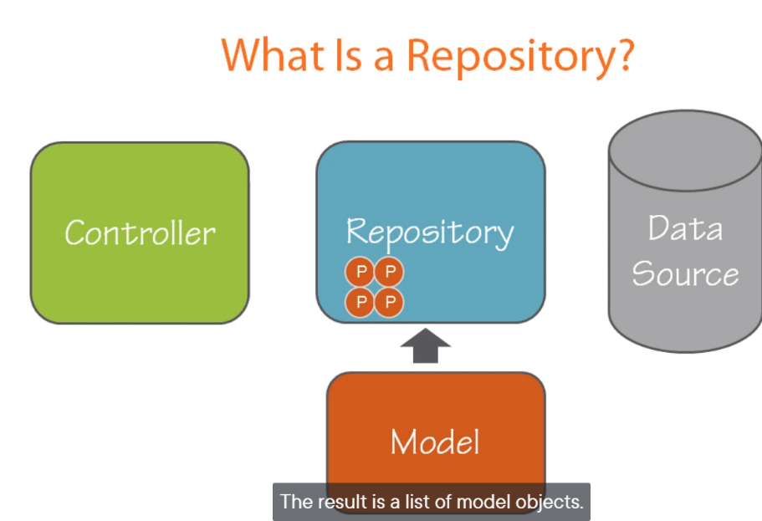

#### Angular Services for calling a web service